Approach to Testing
A structured and systematic approach to testing was adopted to ensure that the Zoo Management System met all functional requirements and operated reliably. The testing process focused on validating core features such as adding animals, generating outputs through polymorphism, and ensuring data integrity within the system.
Testing was carried out using both normal conditions and boundary/error conditions, as required by the specification. Unit testing was implemented using a dedicated test class (ZooUnitTests) to verify individual methods in isolation. In addition, manual testing was performed through the menu-driven interface to simulate real user interaction.
Each test case was designed with clearly defined inputs, expected outputs, and actual outcomes. Screenshots were taken during execution to provide evidence of both the test data input and the resulting output.
Test ID | Description | Test Data input | Expected result | Actual Result | Status
T1 | Add valid animal | Lion("Leo", 5, "gold", 180.5, "large") as shown in fig1 | Animal successfully added, list size increases | Feeding, cleaning, and interface actions executed | Pass
T2 | Add invalid animal | Lion("", -1, "", 0, "") as shown in fig2 | Animal rejected due to invalid data | Animal not added, error message displayed | Pass
T3 | makesound() polymorphism | Parrot("Polly", 2, "green", 1.2, 20) as shown in fig3 | Correct sound returned for parrot | "Squawk! I am Polly..." displayed | Pass
T4 | Search by name | "Leo" as shown in fig4 | Animal details displayed if found | Correct animal displayed | Pass
T5 | Search invalid name | "Unknown" as shown in fig5 |  | Correct error message shown | Pass
  No animal found message
T6 | Daily care functionality | Mixed animals list as shown in fig6 | Feeding, cleaning, and interface actions executed | All actions displayed correctly | Pass
T7 | Report Functionality | Zoo report function input as shown in fig7 | All details should be displayed | All details displayed correctly | Pass
T8 | Remove animal | ‘Leo’ as shown in fig8 | Name should get removed | Name was removed | Pass
T9 | Showcase all animals in zoo | Show all animals function input as shown in fig9 | Should show all animals in zoo | Shows all animals in zoo | Pass
T10 | Remove all animals from zoo | Clear zoo function input as shown in fig10 | All animals should be removed, only after the second confirmation has went through | All animals get removed from the zoo | Pass

Test Evidence-
T1-
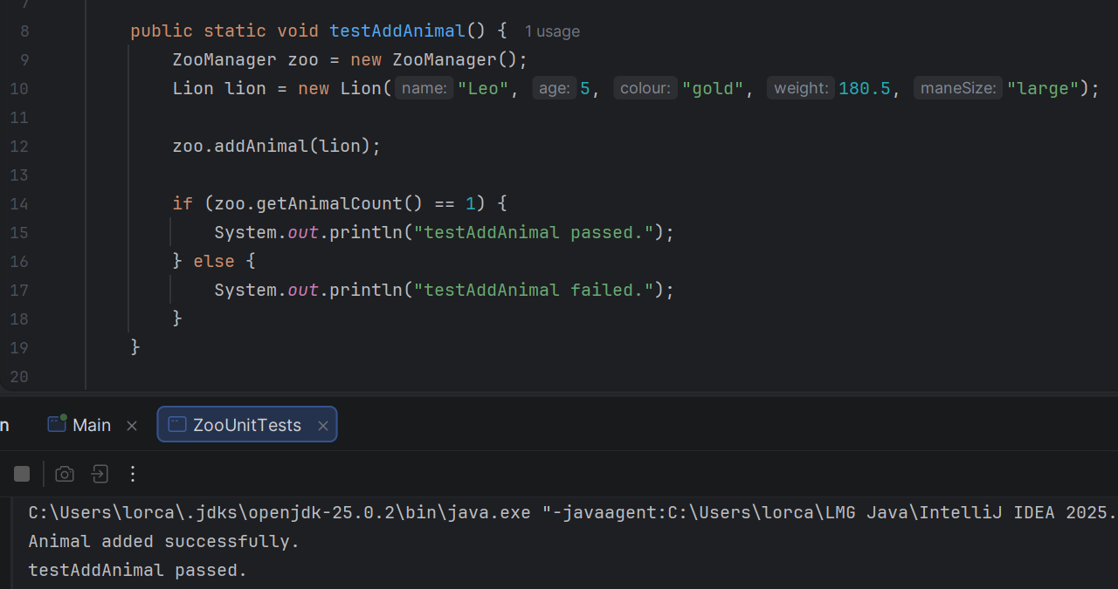
Here we can see how I have used the test data to add an animal to the list and how when ran, the test has performed successfully and the lion animal was added to the list.
Figure 1

T2- Here we can see I have input the test data and when ran, the testAddAnimal section failed due to a lack of data input, proving our test correct therefore gaining a pass.
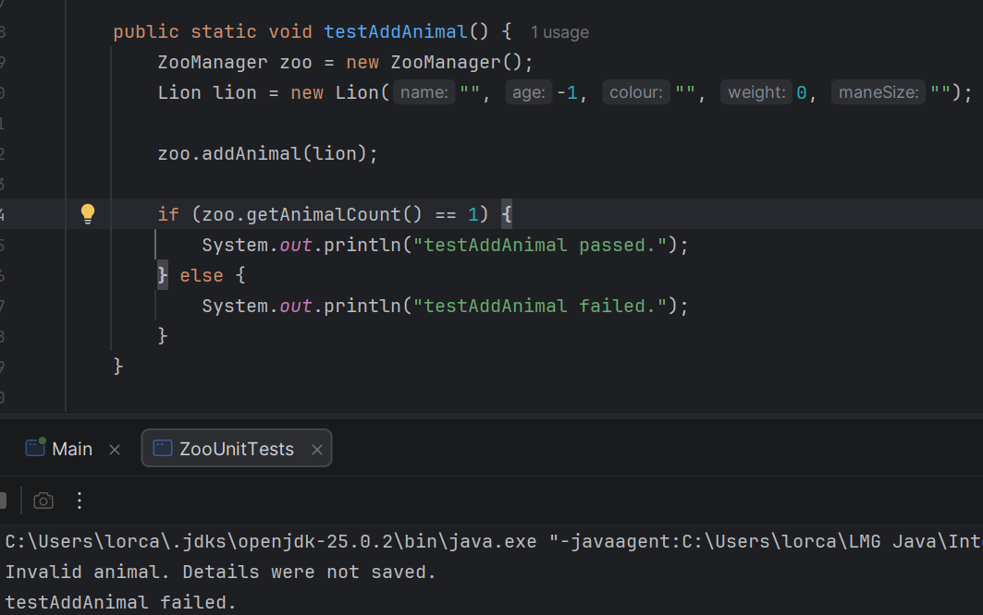
Figure 2
T3-
Here we can see I have input the test data and when ran, the testMakeSound section passed as all the correct data was input and the parrot made the correct sound, proving our test correct therefore gaining a pass.
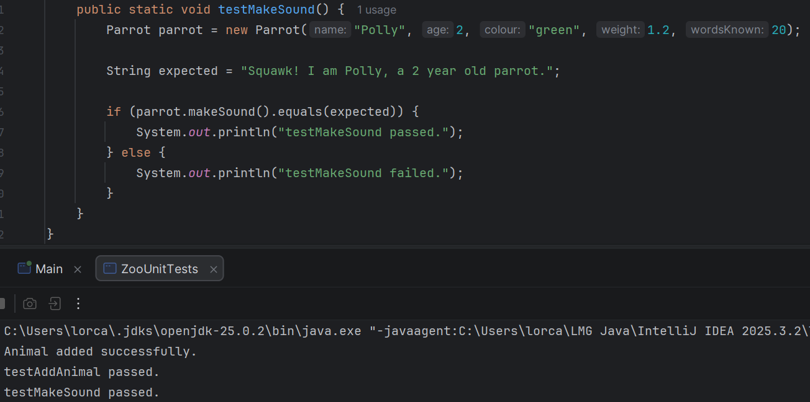
Figure 3
T4-
Here we can see I have used the search animal function in the ‘main’ class. This has allowed for the name of animal to be searched and the information be provided. This has ran successfully therefore gaining this section a pass.
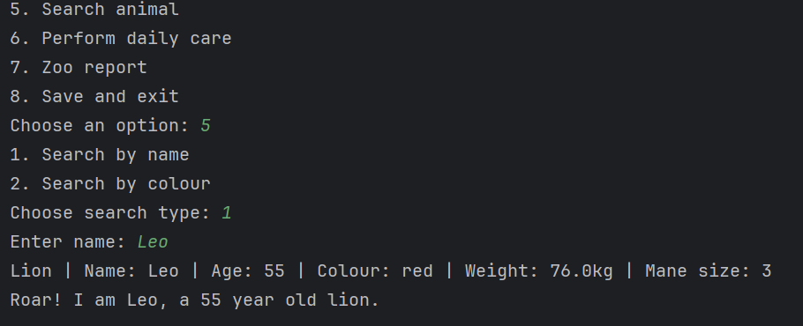
Figure 4

T5-
Here we can see I have used the same search function, only altering the name input to unknown, which there is not an animal in the list known as that, so as it should the system has came back informing the user that there is no animal in the list with that name, therefore giving us the expected result and gaining a pass.
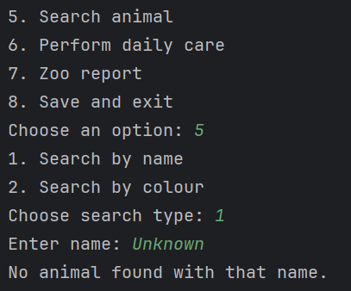
Figure 5
T6-
Here we can see the ‘Perform daily care’ function being run, giving unique statements for each animal, such as wing checks and cleaning. This matches the expected result so therefore receives a pass.
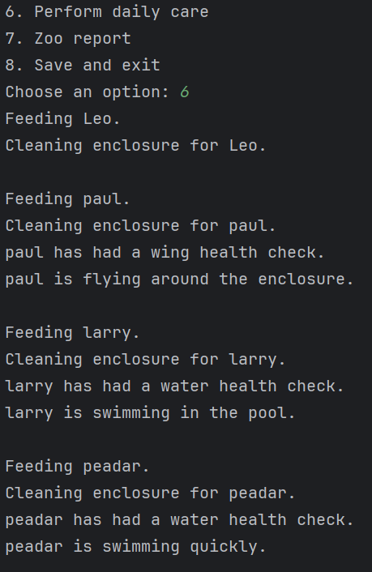
Figure 6
T7- Here we can see how I have selected the zoo report feature and it has displayed all relevant information about the zoo, granting a pass.
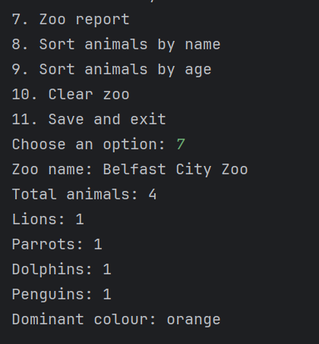
Figure 7
T8- Here we can see how I have clicked the remove animal feature and then the system has asked for the name of the animal to be removed and then proceeded to remove the input animal, therefore granting a pass.
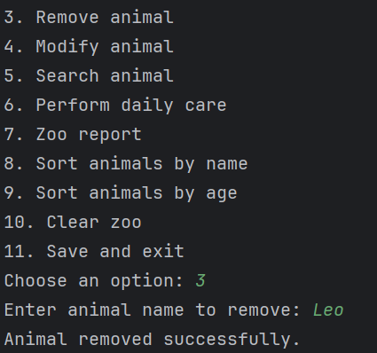
Figure 8
T9- Here we can see I have input ‘2’ so that the system will output all the animals in the zoo, which it has, therefore granting a pass.
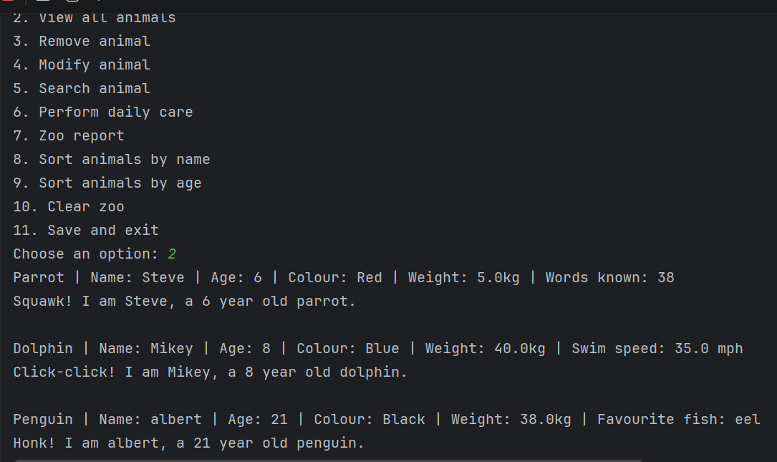
Figure 9
T10- Here we can see I have selected the option for clearing the zoo, the system has then made sure to reassure me to make sure I am selecting the correct option and the proceeds to remove all animals from the zoo, therefore granting a pass.
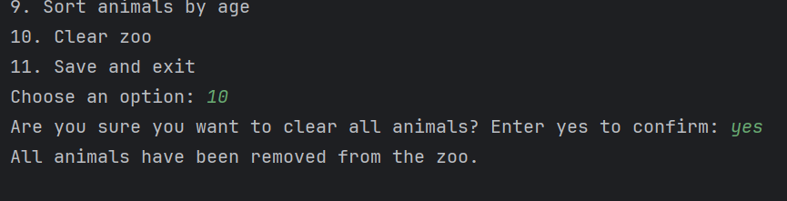
Figure 10
Table 2 A summary of the implementation of each requirement
Requirement | Implemented | Test Case ID Designed
Ability to add an animal | Yes | T1
Ability to search for an animal by name | Yes | T4
Ability to remove an animal | Yes | T8
Ability for zookeeper to perform daily care | Yes | T6
Ability to view all animals at zoo | Yes | T9
Ability to report on the zoo | Yes | T7
Implementation of additional features | Yes | T10

Conclusion
The testing process confirmed that the Zoo Management System meets its functional requirements and behaves correctly under both normal and boundary conditions. The use of unit tests ensured that individual components functioned as expected, while manual testing validated overall system behaviour.
All test cases passed successfully, indicating that key features such as inheritance, polymorphism, and data handling were implemented correctly. The inclusion of validation checks further improves system robustness by preventing invalid data entry. Overall, the system demonstrates reliability, correctness, and adherence to object-oriented principles.

